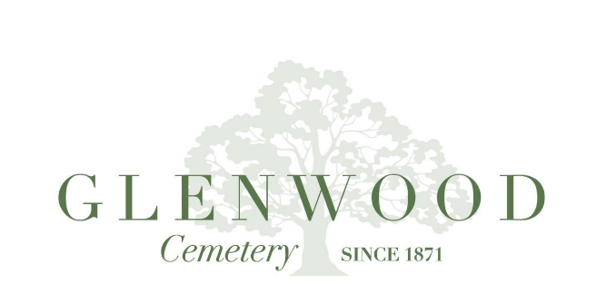

Glenwood Cemetery, Inc. & Glenwood Cemetery Historic Preservation Foundation Archive Collection Use and Reproduction Policy
The Center for Glenwood will provide a place to gather for families, visitors, and community members alike, a place to host events, such as educational seminars, a place to research and connect with the history and legacies memorialized at Glenwood and a place that will help the community to experience all that Glenwood Cemetery has to offer.

The purposes of the Glenwood Cemetery archive are exclusively historical and educational. We aim to preserve, advance, and disseminate knowledge of the history of Glenwood Cemetery and its families; to maintain and curate burial records since 1871, and to protect and preserve its historic integrity and natural beauty. We preserve over 25,000 burial records of both Glenwood Cemetery and adjacent Washington Cemetery, keeping history accessible to all.
The Glenwood Cemetery Archive maintains a large collection of original documents, photographs, and newspaper collections. The Archival collection is available for study and research; however, to preserve original documents and photographs and to maintain the integrity of the collection, none of the materials are allowed to leave the archives or to be reproduced without authorization.
Reproductions or electronic scans may be requested. Fees charged for retrieval, scanning and/or reproducing are listed below. Any material used for publication or used in the public for any reason must be credited “Reprinted with the permission of Glenwood Cemetery, Inc. & Glenwood Cemetery Historic Preservation Foundation”. Clearance of any copyrighted material is the responsibility of the person wishing to publish or display said material.
- Each person requesting reproductions or research by the Glenwood Cemetery staff must fill out the Request for Research/Reproduction form.
- Due to limited staff, requests for materials must be made at least 10 days in advance to allow for processing information.
- Reproduced material may only be used for personal or research purposes. Permission for publication or commercial use will be handled on a case-by-case basis.
- Images may be resized but not altered in any way, reproduced, or sold.
- Students may have photocopies for school projects free of charge however any scanned documents or digitized photos must not be used for any reason other than the project they are working on. Scanned copies of documents would be $1 per document.

Archive Research & Reproduction Fees
Glenwood Cemetery is a non-profit organization. Fees are charged for the research time, retrieval and or reproduction of archive material. Fees also help to maintain the ongoing management of the archival collections.
Photocopies:
Photocopy per page: $1.00
Photocopy of digitized photos
Digital copies and scans: These will be emailed (or sent on a flash drive) to you following receipt of payment:
Retrieval of a pre-scanned item $3.00
Scan of item not already digitized $5.00
Postage: Included in the research fee unless postage exceeds $20.00

Request for Archive research and photographic use
Pre-payment is required for all photographic orders. See fee schedule for prices. Allow 10 days for processing.

Name: ____________________________________________
Address: ____________________________________________
Telephone: ____________________________________________
Email: ____________________________________________
Date Requested: ____________________________________________
Date Due: ____________________________________________
Enclosed Payment: ____________________________________________

Please describe your request with as much detail as you can.

Description of Search Subject | Format (photocopy or scan) | Size | Other Details

Terms of Use: Written permission to publish or display reproductions of Glenwood Cemetery, Inc. archive materials must be secured from the Foundation prior to use of the material. The following credit must be printed under each reproduction: “Reprinted with the permission of Glenwood Cemetery, Inc. & Glenwood Cemetery Historic Preservation Foundation”.
___These reproductions are for personal use only. I agree to be legally responsible for any unauthorized copy, publication, or public display of any reproduction.
___These reproductions are for publication, display or for use by a non-profit or educational organization. I agree to be legally responsible for any unauthorized copy, publication or public display of any reproduction and will credit the Glenwood Cemetery, Inc. for the image. I certify that the information on this form is correct.
I have read and understand/accept the terms of use and agree to pay the fees stated in the GCI policy.

Signature: _________________________________________ Date: ___________________

